Section 3 — External Auditor Report and Certificate 2019/20
In respect of Worthen with Shelve Parish Council — SH0188

Respective responsibilities of the body and the auditor
This authority is responsible for ensuring that its financial management is adequate and effective and that it has a sound system of internal control. The authority prepares an Annual Governance and Accountability Return in accordance with Proper Practices which:
- summarises the accounting records for the year ended 31 March 2020; and
- confirms and provides assurance on those matters that are relevant to our duties and responsibilities as external auditors.
Our responsibility is to review Sections 1 and 2 of the Annual Governance and Accountability Return in accordance with guidance issued by the National Audit Office (NAO) on behalf of the Comptroller and Auditor General (see note below). Our work does not constitute an audit carried out in accordance with International Standards on Auditing (UK & Ireland) and does not provide the same level of assurance that such an audit would do.

External auditor report 2019/20
Except for the matters reported below, on the basis of our review of Sections 1 and 2 of the Annual Governance and Accountability Return (AGAR), in our opinion information in Sections 1 and 2 of the AGAR is in accordance with Proper Practices and no other matters have come to our attention giving cause for condemn that relevant legislation and regulatory requirements have not been met.
e smaller authority has failed to follow proper practices as it has completed, authorised and submitted an AGAR Part 3PM intended for use by Parish Meetings only, rather than an AGAR Part 3, in respect of Section 2 only.
other matters not affecting our opinion which we draw to the attention of the authority:
None.

External auditor certificate 2019/20
We certify that we have completed our review of Sections 1 and 2 of the Annual Governance and Accountability Return, and discharged our responsibilities under the Local Audit and Accountability Act 2014, for the year ended 31 March 2020.
External Auditor Name
External Auditor Signature
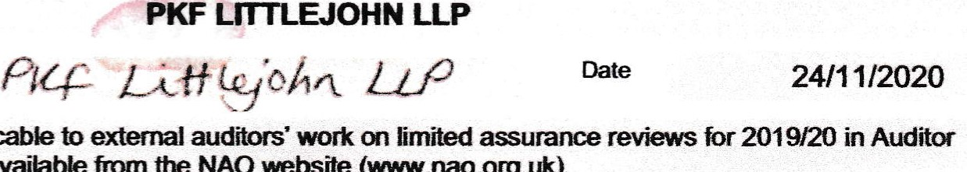
* the NAO issued guidance applicable to external auditors' work
LLP
NAO
website
(www.nao.org.uk)
Guidance Note AGN/02. The AGN is available from

Annual Governance and Accountability Return 2019/20 Part 3 Page 6 of 6

