Worthen with Shelve Parish Council
Notice of conclusion of audit
Annual Governance & Accountability Return for the year ended 31 March 2020
Sections 20(2) and 25 of the Local Audit and Accountability Act 2014
Accounts and Audit Regulations 2015 (SI 2015/234)
Accounts and Audit (Coronavirus) (Amendment) Regulations 2020 (Sl 2020/404)
1.  2.  (a)  3. | The audit of accounts for Worthen with Shelve Parish Council for the year ended 31 March 2020 has been completed and the accounts have been published.  The Annual Governance & Accountability Return is available for inspection by any local government elector of the area of Worthen with Shelve Parish Council on application to:  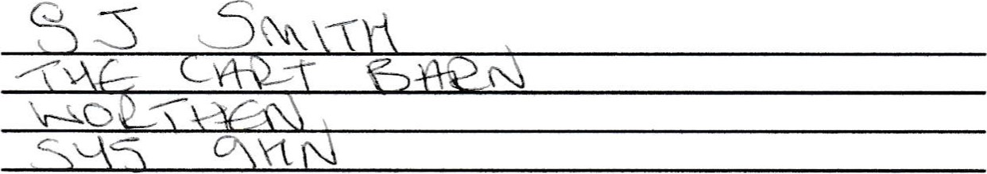  Copies will be provided to any person on payment of E (c) for each copy of the Annual Governance & Accountability Return.  Announcement made by: (d) 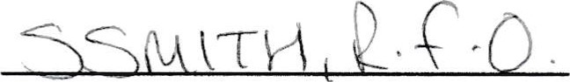  Date of announcement: (e) 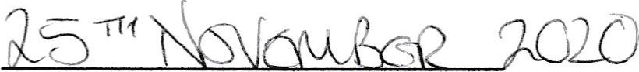 | Notes  This notice and 1, 2 & 3 of the AGAR must be by 30 November. This must Include publication on tie smaller authorities website. The smaller authority must decide how long to publish the Notice for, the AGAR and external auditor report must be publicly available for 5 years.  - Insert the name, position and address of the person to whom local government electors should apply to inspect tie AGAR  - Insert the hours during which rights may be exercised  - Insert a reasonable sum for copying costs  - Insert the name and position of person placing the notice  Insert the date of placing of the

